**A HIGH-LEVEL DESIGN DOCUMENT FOR FLIPKART**

# **Overview or Introduction:**

Flipkart is a leading e-commerce platform in India, offering a wide range of products including electronics, fashion, home essentials, and more. To provide users with a seamless shopping experience, enabling them to browse, search for, and purchase products conveniently from their devices.

* 1. **Purpose of this document:**

The purpose of a High-Level Design (HLD) is to provide an overview of a system or application at a conceptual level. It serves as a blueprint for the system's architecture, outlining its key components, functionalities, and interactions without diving into implementation details.

* 1. **Document Scope:**

To define the scope of the Flipkart application in terms of its high-level design, architecture, and key functionalities.

1. **Requirements Summary:**

**User Authentication and Management**

* Users should be able to create accounts, log in securely, and manage their profiles.
* Support for password recovery and account management features such as profile updates and password changes.

**Shopping Cart and Checkout**

* Users should be able to add products to their shopping carts, view cart contents, and modify quantities.
* Seamless checkout process with support for multiple payment methods including credit/debit cards, net banking, UPI, etc.
* Integration with payment gateways for secure payment processing and order fulfilment.

**Product Catalog Management**

* Display a diverse range of products across various categories including electronics, fashion, home essentials, etc.
* Each product listing should include details such as images, descriptions, prices, ratings, and reviews.
* Support for browsing, searching, and filtering products based on different criteria.

**Order Management**

* Users should be able to track the status of their orders, view order history, and manage returns and cancellations.
* Notifications to keep users informed about order status updates, delivery schedules, and promotions.

**Customer Support**

* Provide channels for customer support including FAQs, live chat, email, and phone support.
* Help users resolve issues related to orders, payments, returns, etc., in a timely and efficient manner.

**Security and Privacy**

* Secure transmission of sensitive data (e.g., user credentials, payment information) using encryption protocols like HTTPS.
* Protection against common security threats such as cross-site scripting (XSS), SQL injection, and session hijacking.
* Compliance with privacy regulations and best practices for handling user data responsibly.

1. **Assumptions and prerequisites:**

**Internet Connectivity:**

* Users must have access to a stable internet connection to use the Flipkart application.

**Supported Platforms:**

* The Flipkart application will be accessible via web browsers on desktop and mobile devices.
* Native mobile applications will be available for popular platforms such as iOS and Android.

**Device Compatibility:**

* The Flipkart application will be compatible with a wide range of devices, browsers, and screen sizes to ensure a seamless user experience across platforms.

**Payment Gateways:**

* Integration with third-party payment gateways will be required to facilitate secure online transactions.
* Prerequisites include establishing partnerships with payment service providers and obtaining necessary credentials for payment processing.

**Product Suppliers:**

* Flipkart will collaborate with various product suppliers and vendors to populate its product catalog.
* Prerequisites include establishing partnerships, obtaining product data feeds, and ensuring compliance with supplier agreements.

**Data Privacy and Security:**

* Compliance with data privacy regulations such as GDPR (General Data Protection Regulation) and PCI DSS (Payment Card Industry Data Security Standard) is essential.
* Prerequisites include implementing robust security measures, data encryption, and privacy policies to protect user information.

**Customer Support:**

* Prerequisites include establishing customer support channels such as email, live chat, and phone support to assist users with inquiries, issues, and feedback.

**Continuous Improvement:**

* Continuous monitoring, feedback collection, and iterative improvements will be integral to enhancing the Flipkart application's user experience and functionality.
* Prerequisites include implementing feedback mechanisms, conducting usability testing, and prioritizing feature enhancements based on user feedback and market trends.

1. **High-Level Design:**

High-Level Design is a general system design and includes the description of the system architecture and design. It aims to provide process flow updates and information pathway changes using diagrams, tables, and other visualizations. Typically, also addresses integration issues with other systems.

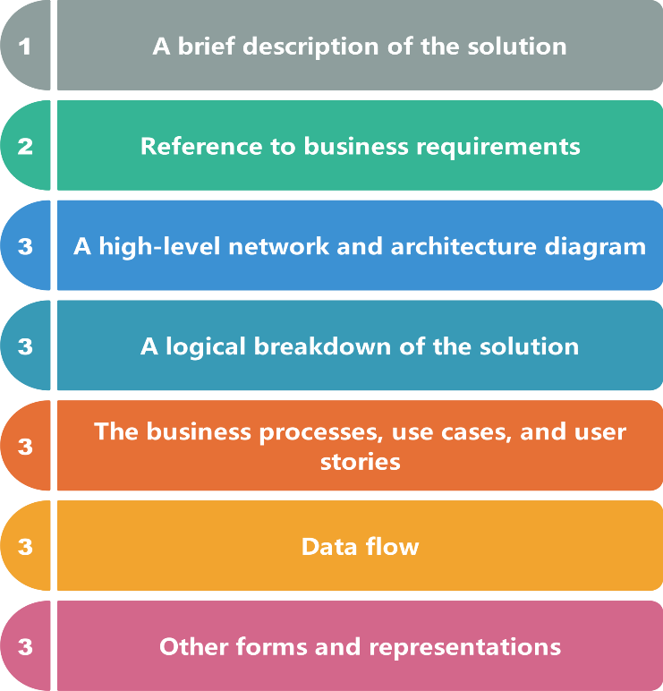

**Fig: The flow of HLD**

**4.1 Features:**

**a) User Management:**

* Top of Form
* User login, registration and authentication.
* User has profile management that includes address, payment methods and preferences.

**b) Shopping Cart:**

* Shopping cart functionality for users to add, remove and modify items.

**c) Checkout:**

* Guest checkout and user account checkout with saved addresses and payment methods.

**d) Order Management:**

* Order tracking and status updates for users.
* Order processing include order confirmation, packaging and shipping.

**e) Search and Navigation:**

* Advanced search functionality with filters and sorting options.
* Navigation through categories and sub-categories.

**f) Reviews and Ratings:**

* User reviews and ratings for products.
* Aggregate ratings displayed on product pages.

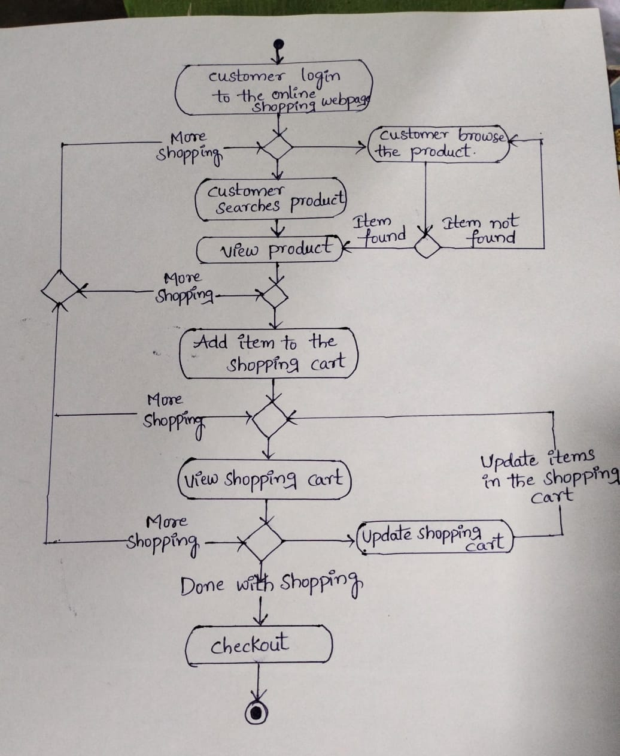

**4.2 Application Modules:**

* **Core system components:**

**The components are developed by using java, and these are structured as microservices allowing for independent development, deployment and scalability.**

* **User interfaces:**

**The user interfaces are developed by using HTML, CSS and JavaScript for web interfaces**and JavaFX for desktop interfaces. These interfaces are interacted with backend microservices through RESTful APIs, ensuring seamless communication between frontend and backend layers.

* **The database layer:**

The database layer is developed by using MySQL, MongoDB to fetch the data and these databases are accessed through SpringDataJPA for efficient data manipulation.

* **The business logic:**

It is implemented through backend microservices using java and it handles tasks such as user authentication, payment validation etc.

* **Application Programming Interfaces (APIs):**

**Flipkart integrates with external systems and services through APIs to extend its capabilities.**

**4.3 Data flow and Use cases:**

The data flow and use cases section contain the document all necessary interactions between the user and the system.